Welcome to Union United Methodist Church! We are glad you have chosen to worship with us today! Our ushers are ready to provide any assistance you might need. Our nursery is open 8:30 – Noon for ages infant to five years old. The entrance is located in the lobby. We also have available large print hymnals, hearing assistive devices, wheelchairs and an elevator. If you are interested in speaking with Pastor Angie, please call the church office at 618-233-6375.

All that are able please stand
Bold type: Please join in

Welcome & Announcements Pastor Angie Lee

Gathering: Entering God’s Presence with Thanksgiving and Praise

Prelude Eventide Gail Long
Diane Bish

Bringing in the Light of Christ and the Word of God

Choral Introit Become to Us the Living Bread

*Call to Worship Carl Buehler
Leader: In the quiet of the night, Nicodemus came seeking truth.
People: In the stillness, Jesus spoke of new birth in the Spirit.
Leader: We come with our questions, our doubts, our longings.
People: And God meets us with grace, offering new life.
Leader: Come, let us worship the God of amazing grace and transforming Spirit.
People: As we come seeking renewal, longing to be born again by water and
the spirit, our God, breathe on us, that our hearts may be open and our
lives transformed. Amen.

*Opening Hymn Amazing Grace #378

Response: Offering Ourselves to God

Prayer and the Lord’s Prayer Pastor Angie

Prayer Response

Offertory Wem in Leidenstagen
Robert A. Hobby

*Doxology #95

*Hymn of Response Spirit of the Living God #393
Sing Twice

Proclamation: Hearing God’s Word

Children’s Sermon Angela Rawson
(Children ages K-4th grade are dismissed to junior church.)

Scripture John 3:1-17
Reader: This is the word of God, for the people of God.
People: Thanks be to God.

Anthem O Living Bread of Heaven
Larson

The Message “Born Again into Grace” Pastor Angie

Communion with God: Holy Communion

Communion Liturgy Pages 12-14

Communion Instructions
Union UMC practices OPEN Communion, whereby all are invited to receive the elements. You do not have to be a member of Union United Methodist Church or any church to partake of these symbols of God’s grace. This is God’s table, and you are always welcome! Please consider yourself invited.

Sending: Going with Blessings to Become Church in This World

*Sending Hymn Hymn of Promise #707

*Sending Word with Benediction

*Benediction Response

Postlude O Sacred Head Now Wounded
Brian Büda

Taking the Light of Christ and the Word of God into the World

Communion Stewards: Jo Lynn and Helen Rinehart

COMMUNION OFFERING: It has been the tradition of most UMC’s and of UUMC to receive a special offering during communion. Those funds go into the Pastor's Discretionary Fund to assist those with special needs. You are invited to bring your gift forward as you receive communion. Baskets are placed near the front pews.
●──────────────────────────●

Please join us immediately following the worship service
in the McKinley Hall for coffee and fellowship time.
●──────────────────────────●
The altar flowers are given by:
Beverly Ruser
To the Glory of God
●──────────────────────────●
Greeters: Mark and Debbie Tiemann

Sermon Notes:

Sunday Education
*Ages 3-4 years, Room 303 *Fifth & Sixth Grade, Room 207
*Kindergarten, Room 203 *Junior & Senior High, Room 211
*First & Second Grade, Room 204 *Forum Class, Room 217
*Third & Fourth Grade, Room 208

Lower Level, Rooms 100’s
Children/Rehearsal Level, Rooms 200’s
Nursery, Room 303
Sanctuary Level, Rooms 300’s
Balcony Level, Rooms 400’s
UNION
UNITED METHODIST
CHURCH

721 EAST MAIN STREET
BELLEVILLE, IL 62220
618-233-6375
www.unionumc.org

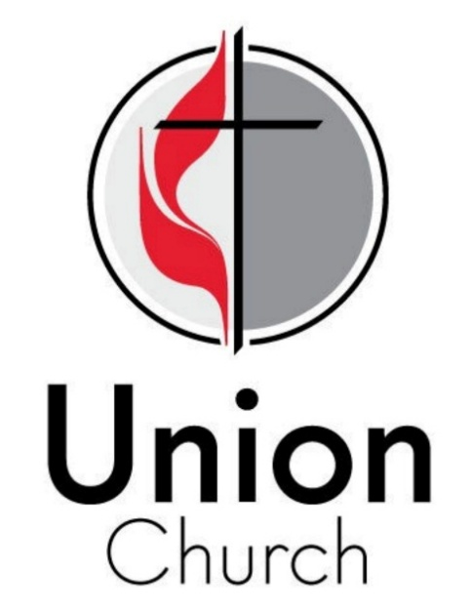

Mission Statement:
“Developing followers of Jesus Christ
to serve the World”

March 1, 2026
9:00 a.m.

Next Sunday: Girl Scout Sunday
“You Don’t Miss Your Water”
Exodus 17:1–7; John 5:4-30
Bishop David Alan Bard

